

P. Swetha Nagasri

Dadi Teja Sadwika

2520030536
CSE
CO3 – Graph Traversal and Minimum Spanning Tree Algorithms

Case Study Topic: RailConnect – Railway Network Optimization System (CO3 Focus: Graph Traversal and Minimum Spanning Tree)

Work Done Summary:
RailConnect is a railway network optimization system developed to manage railway station connectivity and minimize track construction costs. The system uses Graph Traversal algorithms such as Breadth First Search (BFS) and Depth First Search (DFS) to analyze station connectivity and route accessibility. Minimum Spanning Tree algorithms such as Kruskal's Algorithm and Prim's Algorithm are used to design a cost-effective railway network by connecting all stations with minimum possible cost. This system helps railway authorities improve route planning, reduce infrastructure expenses, and ensure efficient transportation management.

Implementation Details:
- Railway stations are represented as vertices in a graph.
- Railway tracks are represented as edges connecting stations.
- BFS is used to visit all reachable stations from a source station.
- DFS is used to explore the complete railway network.
- Kruskal's Algorithm is applied to construct a minimum-cost railway network.
- Prim's Algorithm is used to generate an optimized spanning tree.
7. The system ensures connectivity among all stations.
8. Infrastructure cost is minimized while maintaining efficient transportation routes.

Output:

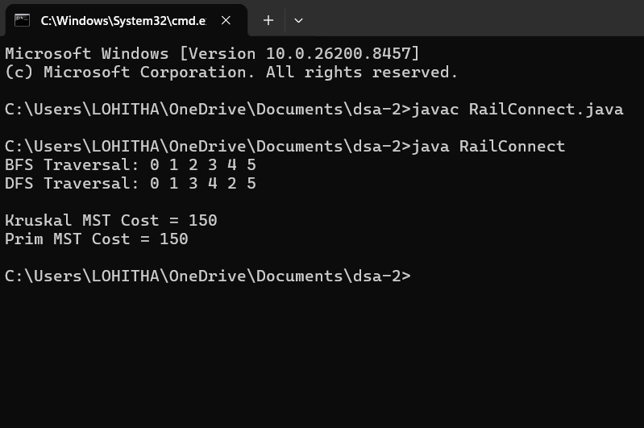

RailConnect effectively manages railway connectivity using graph algorithms. BFS and DFS help analyze station accessibility and network traversal, while Kruskal's and Prim's Algorithms construct a minimum-cost railway network. The system improves transportation planning, reduces construction expenses, and ensures efficient railway connectivity.

Github link:

